Mid-Norfolk Conservative Association
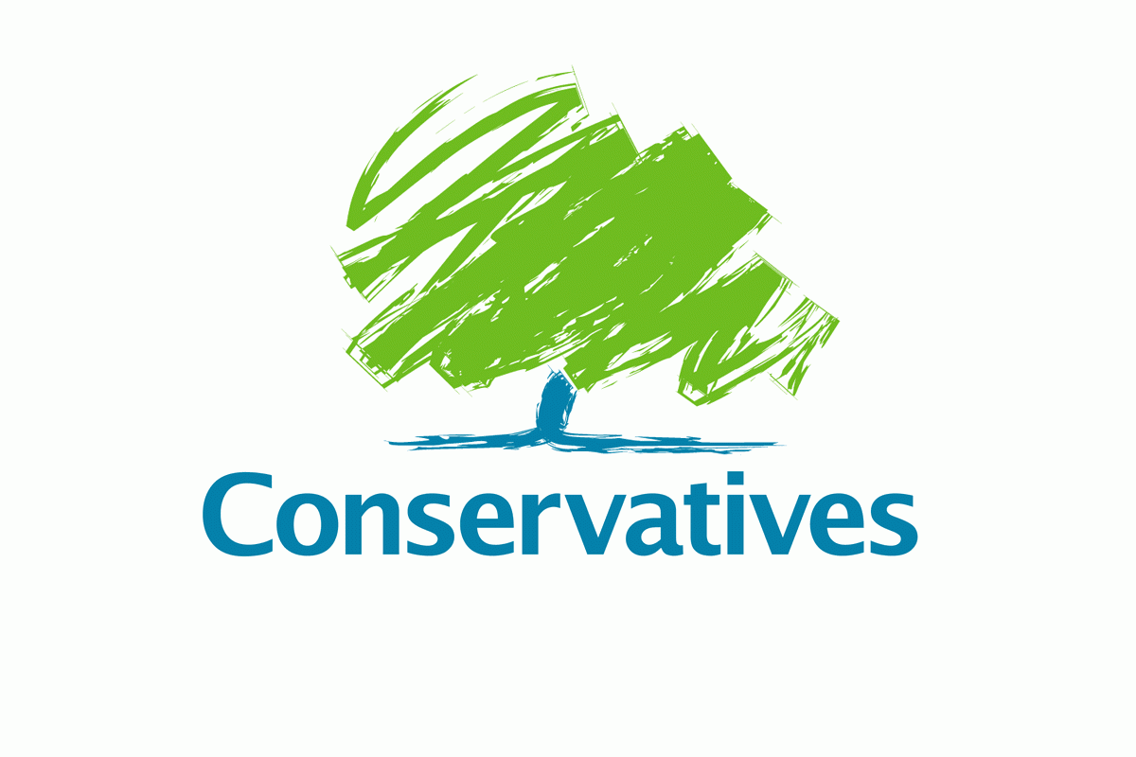
Monday 16th April 2018

Dear Member,

On 25th of May 2018, new rules come into force under the General Data Protection Regulation (GDPR) which governs the way all organisations collect data.
We would be disappointed for you miss out on Mid-Norfolk Conservatives news and updates. Please update your details and preferences by completing this form and send it to us by e-mail or post, we have enclosed a SAE.
If we do not have these instructions from you, the Law will obliged us to stop communicating with you on 25th of May.

The fields marked thus * must be completed if we are to meet the requirements of the GDPR.
You can also contact the Association by phone on 01953 603742 or email midnorfolkconservatives@gmail.com. This form is also available on the website at www.midnorfolkconservatives.org.uk.

Best wishes, Jamie Athill, Chairman MNCA

Title * |  | Last Name *
First Name(s) *
Address: Line 1 *
Address: Line 2
Address: Line 3
City * | County * |  |  | Post Code *
Landline phone no. |  | Mobile phone no.
Email address *
Signature * |  |  | Date *

PLEASE INDICATE HOW WE MAY CONTACT YOU
Email *
Post *
Text to your Mobile Phone *
Voice to your Landline Phone *

